Consider a PL/SQL code that accepts 2 numbers & return addition, subtraction, multiplication & division of two numbers using stored functions and local function.

Solution

1. Create stored functions to perform the arithmetic operations.

2. Use local functions within the main procedure or function to invoke the stored functions and perform calculations.

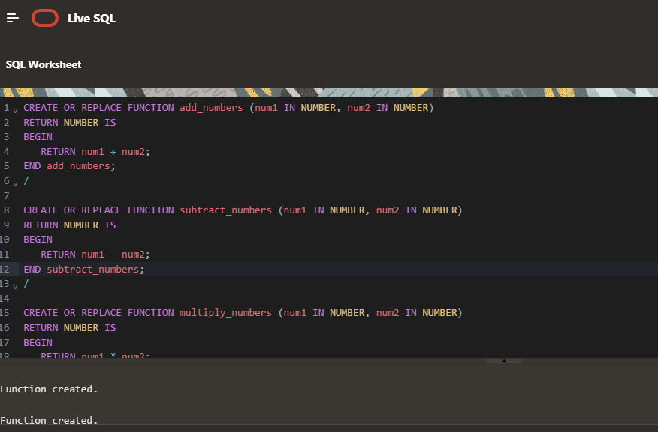

CREATE OR REPLACE FUNCTION add_numbers (num1 IN NUMBER, num2 IN NUMBER)

RETURN NUMBER IS

BEGIN

RETURN num1 + num2;

END add_numbers;

/

CREATE OR REPLACE FUNCTION subtract_numbers (num1 IN NUMBER, num2 IN NUMBER)

RETURN NUMBER IS

BEGIN

RETURN num1 - num2;

END subtract_numbers;

/

CREATE OR REPLACE FUNCTION multiply_numbers (num1 IN NUMBER, num2 IN NUMBER)

RETURN NUMBER IS

BEGIN

RETURN num1 * num2;

END multiply_numbers;

/

CREATE OR REPLACE FUNCTION divide_numbers (num1 IN NUMBER, num2 IN NUMBER)

RETURN NUMBER IS

BEGIN

IF num2 = 0 THEN

RETURN NULL; -- To avoid division by zero

ELSE

RETURN num1 / num2;

END IF;

END divide_numbers;

/

